[1]

ME 330 Mechatronics Laboratory

Lab 1 – Manual Circuits

Nicholas Agtual, Dalaney Conte, Evaline Cuatok, Josh Gipson

Department of Mechanical Engineering

Spring 2022

**Abstract**

The goal of the Manual Circuits lab experiment is to gain an understanding of basic circuit building concepts using physical circuits and simulated circuits. The lab is also intended to point out the differences between the physical and simulated circuits, displaying the limitation of using ideal cases. A voltage divider, half wave rectifier, and capacitor charging and discharging circuit were created using simulation and physical components. Comparison of the two showed the importance of tolerances of components and inherent resistance in wires.

Table of Contents

1 Introduction and Objectives 4

1.1 Objectives 4

1.2 Required Components 4

2 Voltage Divider 9

2.1 Simulated Circuit 10

2.2 Physical Circuit 11

2.3 Lab Questions 11

3 Halfwave Rectifier 12

3.1 Simulated Circuit 13

3.2 Physical Circuit 13

3.3 Lab Questions 13

4 Capacitor Charging and Discharging 14

4.1 Simulated Circuit 14

4.2 Physical Circuit 14

4.3 Questions 14

5 Conclusion 15

6 References 16

7 Appendices 17

Table of Figures

Figure 1: Breadboard Connectivity 4

Figure 2: 4 & 5 Band Resistor Color Code 4

Figure 3: National Instruments ELVIS II Breadboard 5

Figure 4: 10k Resistors 5

Figure 5: 100k Resistors 5

Figure 6: 22F Ceramic Capacitor 6

Figure 7: Junction Diode 6

Figure 8: Momentary Push Button Switch 6

Figure 9: (a) Simple Voltage Divider (b) Circuit with a Node of Three Resistors 7

Figure 10: Voltage Divider Simulated Circuit 8

Figure 11: 5 Load in Parallel With 10k Resistor in a Voltage Divider 10

Figure 12: Half Wave Rectifier Simulated Circuit 10

Table of Tables

Table 1: Voltage Divider Voltages and Currents 9

Table of Equations

Equation 1 4

Equation 2 8

Equation 3 8

Equation 4 8

Equation 5 8

Equation 6 8

# Introduction and Objectives

## Objectives

The Manual Circuits lab is intended to provide students with a basic overview of circuit building, whether that be simulated circuits or physical circuits, and analysis of said circuits. Multisim, a circuit building software, was used to construct the simulated circuits and determine important values within those circuits. The National Instruments ELVIS II breadboard was used to construct and make measurements on the physical circuits. In this lab, the following three circuits were constructed: voltage divider, halfwave rectifier, and capacitor charging and discharging circuit.

## Required Components

In this experiment the major components used were the National Instruments ELVIS II breadboard, resistors, capacitors, and diodes. The National Instruments ELVIS II breadboard as seen in Figure 1 served as the building platform for the physical circuits. Breadboards have power rails that run vertically along the sides. These buses are colored with red (+) and blue (-) and are connected vertically. Contrarily, the rows in the main section of the breadboard are connected except when interrupted by a break in the middle of the board (See Figure 1 for a visual representation of breadboard connectivity). The This breadboard, in conjunction with the National Instruments software, also provided the variable power supply, digital multimeter, function generator, and oscilloscope [3].

Figure 1: Breadboard Connectivity

Resistors are passive electrical components that depending on their placement and orientation within a circuit, in their most basic use, serve to change the current or voltage at a point within a circuit [1]. Resistance is defined by the resistivity of a material (), the length of the wire (L), and the cross-sectional area of the wire (A) as seen in Equation 1. Resistors have a color convention that allows one to determine the resistance and tolerance of the elements. The color code can be seen in Figure 2.

|  |  |  |
| --- | --- | --- |
|  |  | Equation 1 |

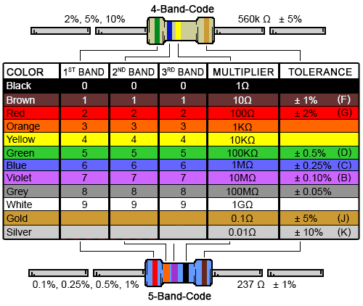

Figure 2: 4 & 5 Band Resistor Color Code

Capacitors are passive electrical elements that store energy in the form of electric fields [1]. Capacitors are measured in units of Farads which are equal to coulombs over volts [1]. There are various types of capacitors, but the most common and simplest capacitors is made of two parallel conducting plates that are separated by a dielectric material. Capacitors can store and discharge energy and do not let DC current flow through. Because of this the main function of capacitors is energy storage, but they have a myriad of different uses.

Lastly, the use of junction diodes in this experiment allowed for the construction of the half wave rectifier circuit. A junction diode is an electrical component that allows the flow of current only in one direction. This is known as biasing; in forward bias, the current is allowed through the diode and in reverse bias the current may not flow through the diode. A diode in forward bias acts like a switch in series with a voltage source (forward voltage) and a forward dynamic resistance [2]. When the diode is in reverse bias, it acts as an open switch in parallel with an internal reverse resistance [2].

The specific number and values of the required components can be seen below:

* 1x National Instruments ELVIS II Breadboard

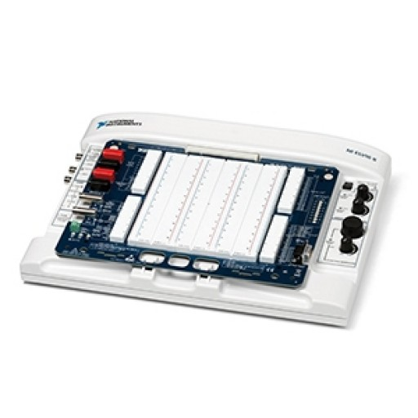

Figure 3: National Instruments ELVIS II Breadboard

* 1x 10k resistor (Brown, Black, Black, Red, Brown)

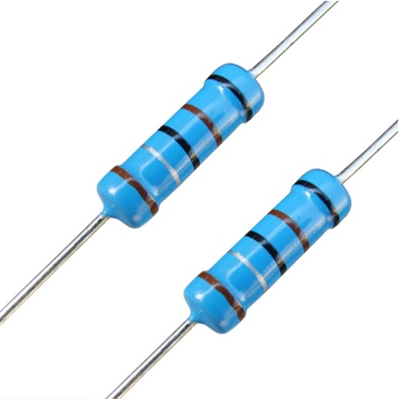

Figure 4: 10k Resistors

* 1x 100k resistor (Brown, Black, Black, Orange, Brown)

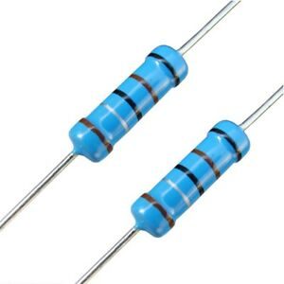

Figure 5: 100k Resistors

* 1x 22F capacitor

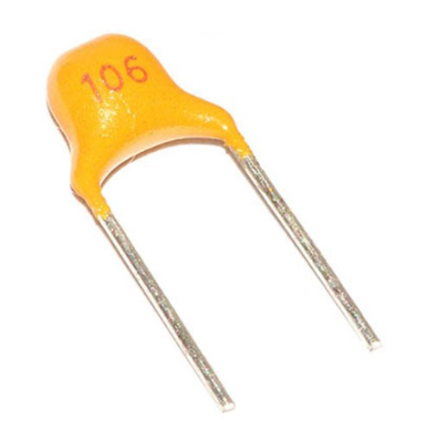

Figure 6: 22F Ceramic Capacitor

* 1x Diode

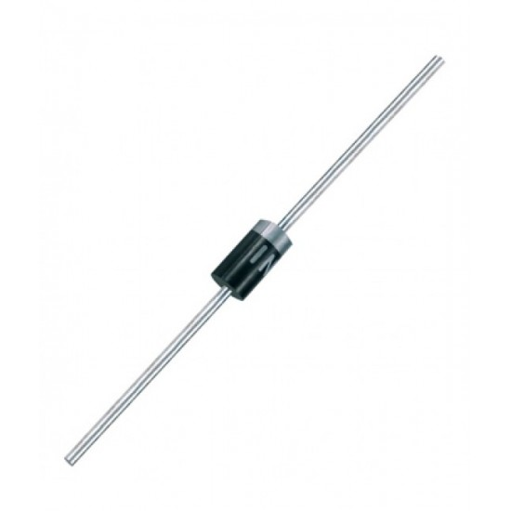

Figure 7: Junction Diode

* 1x Momentary Pushbutton Switch

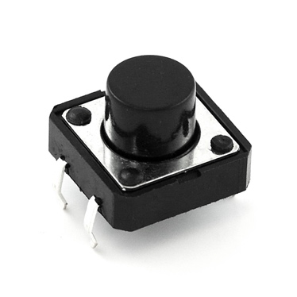

Figure 8: Momentary Push Button Switch

# Voltage Divider

A voltage divider is a type of circuit constructed with the goal of producing an output voltage () that is a fraction of the input voltage (. By adjusting the values of the resistor and whether they are connected in series or parallel, one can alter the voltage drop across each resistor to achieve a desired voltage. This allows the proper voltage to be applied to any load for safe operating conditions regardless of the source voltage.

Figure 9 (a) displays a simple voltage divider circuit with two resistors connected in series. The output voltage (), which in this case is measured at the junction of the two resistors, can be calculated using Equation 3 and Equation 4. Additionally, the input voltage () which is the voltage of the source can be calculated using Equation 2.

|  |  |  |
| --- | --- | --- |
|  |  | Equation 2 |
|  |  | Equation 3 |
|  |  | Equation 4 |

Figure 9: (a) Simple Voltage Divider (b) Circuit with a Node of Three Resistors

Equation 2 and Equation 3 use the Ohm’s Law (Equation 5) to solve for the voltage-current relationship for a resistor.

|  |  |  |
| --- | --- | --- |
|  |  | Equation 5 |

In the case that a third resistor is connected in parallel with one of the resistors in the voltage divider circuit ( in Figure 9 (b)), the input current is split between the two depending on their values. By applying Kirchhoff’s Current Law, the current through can be calculated (See Equation 6).

|  |  |  |
| --- | --- | --- |
|  |  | Equation 6 |

## Simulated Circuit

The circuit seen in Figure 10 can be created using software such as Multisim. The circuit is a voltage divider with a DC source connected in series with a and resistor. In this simulated circuit, the voltage and current are measured at the junction of the two resistors. The voltage at this node reads and the current reads flowing from the resistor to the resistor.

Figure 10: Voltage Divider Simulated Circuit

## Physical Circuit

To create this circuit, the Elvis II breadboard shown in Figure 3 is used. Like the procedure described for the Similar Circuit the 5 V DC source is connected in series with the 100 kΩ resistor shown in Figure 5 using the wires provided. Additionally, the 5V DC source will be connected to ground. The 100 kΩ resistor is then connected in series with the 10 kΩ resistor shown in Figure 4. Then a wire connecting the 10 kΩ resistor will be connected to ground. After the circuit was created both the voltage and the current are measured by connecting a wire in between the 10 kΩ resistor and ground to the input signal. The voltage was found to be 4.514 V and the current was found to be 40 µA.

## Lab Questions

1. **Compare the calculated, simulated, and measured voltages and currents.**

Table 1: Voltage Divider Voltages and Currents

|  |  |  |  |
| --- | --- | --- | --- |
|  | **Calculated Values** | **Simulated Values** | **Measured Values** |
| **Voltage** |  |  |  |
| **Current** |  |  |  |

1. **How much did the values differ? Describe the reason the values differ.**

The voltage and current values for the simulated circuit and those achieve through calculation had no deviation. On the other hand, the measured voltage and current values measured from the physical circuit did vary slightly. The voltage reading for the physical circuit was less than that of the simulated and calculated values and the current was less. This is since the values from the calculations and simulated circuits both assumed ideal wires (no resistance), when, all the jumper cables and breadboard junctions have inherent resistance. The calculated values and simulated circuit values also did not account for resistor tolerances. The resistor values were not exactly and ; see Figure 18 for true value. Another possible area that caused deviation is that the NI digital multimeter only read current in Amperes up to 5 decimal points. This means that values in the range must be rounded or truncated.

1. **When measuring the physical circuit, did the values change at all during measurement? By how much? What may have caused the variation in the output?**

When reading the measured values for the physical circuits, the values slightly fluctuated. This is most likely due to a few assumptions made not being true for the physical circuit. The DC voltage is assumed to be perfectly constant when this value has minor variations, thereby affecting the readings. This could also be because as the components are in use, they can heat up, which would affect their properties. The magnitude of these fluctuations, however, is not very large.

1. **If a load of 5Ω is connected in parallel to the 10K resistor (See Figure 11)** 
   1. **How much current is drawn by the 5Ω load?**

The current drawn by the 5Ω load is 49.973 µA.

* 1. **What is the voltage across the 5Ω load?**

The voltage across the 5Ω load is 0.2499 mV.

* 1. **Would you expect the current and voltage to be much different if the 5Ω load were connected to the physical circuit?**

If the 5Ω load were to be connected to a physical circuit, the results would not be too different from the simulated values. There would be some variance for a couple reasons. First, the ELVIS board and the jumper cables all have some internal resistance while the simulation assumes ideal parameters and thus there would be no internal resistance. Second, the resistors that are used in lab have allowable tolerances and therefore are not exactly the same as the simulated ones.

* 1. **Based on the results, what resistance should R1 be changed to for the voltage output to be the same as that in figure 1?**

For the voltage output to be the same as that in figure 1 the total resistance would have to be equal to 110 kΩ because that is the total resistance of the circuit when the 10 kΩ and 100 kΩ resistor are in series. When the 5Ω load is added in parallel to the 10 kΩ resistor, the equivalent resistance of the two components is 4.9975 Ω. When 110 kΩ is subtracted from 4.9975 Ω, the resistance for R1 would be 109.995 kΩ.

* 1. **Could the resulting voltage from the original circuit as shown in Figure 11 be obtained by changing the value of R2?**

Figure 11: 5 Load in Parallel With 10k Resistor in a Voltage Divider

No, it is not possible to get the resulting voltage from the original circuit by changing the value of R2. In order to get the resulting voltage from the original circuit, the equivalent resistance between R2 and the 5 Ω load would have to be equal to 10 kΩ. With the 5 Ω load in parallel to the 10 kΩ resistor, this is impossible because the equivalent resistance can never be larger than the resistance of any of the individual resistors.

1. **Based on the results of questions 1 – 4, is a voltage divider a good way to make a voltage source? Why or why not?**

Based on the results of questions 1- 4, a voltage divider is not a good way to make a voltage source. The voltage divider causes the output voltage to be lower than what is desired.

# Halfwave Rectifier

A halfwave rectifier converts the full AC sinusoidal supply voltage to one-half of the cycle. By only permitting positive voltage, this halfwave rectifier converts the AC signal to DC. The rectifier constructed in this experiment is constructed with a diode in series with a resistor which converted a sinusoidal wave into the positive half cycle of the AC wave. When using devices that require DC current, halfwave rectifiers help power those devices with AC current.

## Simulated Circuit

Figure 12: Half Wave Rectifier Simulated Circuit

In Figure 12, the schematic of our simulated circuit can be seen for the halfwave rectifier part of this experiment. This circuit consists of a 5V AC current running at a frequency of a 100Hz. The current then flow through a resistor. The current then flows through a diode and then to ground. The halfwave rectifier in this circuit is the diode as it only takes one-half of the AC voltage wave. Since we used an AC Voltage, it was best to use the transient graph to see our peak-to-peak voltage.

## Physical Circuit

There were a few challenges when construction the physical halfwave rectifier. One of the first changes was determining the direction of the diode; our initial readings on the oscilloscope gave the negative half of the wave and to change this, the direction of the diode was switched. This showed the importance of the oscilloscope when building circuits. The second error visible in our circuit, was the difference in peak voltage. As seen in Figure 15, the peak voltage is 3.005V, while the ideal circuit was meant to be supplied by 5V. The difference in voltage can be attributed to the age of the breadboard and the attrition the board has faced over the years as well as the inherent internal resistance. This would affect the data between our physical and simulated circuits severely since the physical circuit is experiencing a different source voltage compared to the simulated circuit.

## Lab Questions

1. **Compare the input and output measurements you made between the physical and simulated circuits. Discuss the differences.**

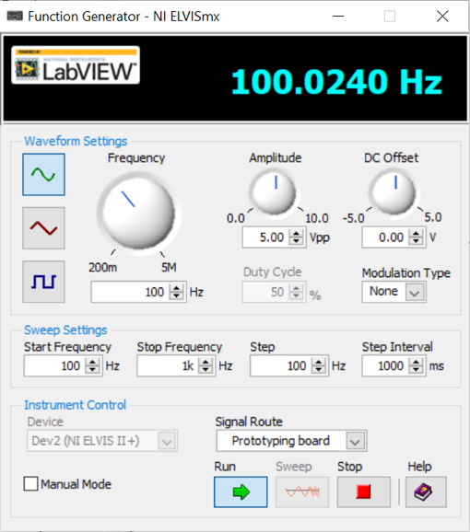

Figure 13: Halfwave Rectifier Frequency

The recorded Frequency can be seen in Figure 13. The expected value for the frequency was 100Hz and the recorded value was 100.024 Hz. There is very little error since our expected and recorded values are very close. The error between the numbers could be due to the wear on the circuits and the tolerances within the resistor and breadboard.

Figure 14: Expected Voltage Output Signal

Figure 15: Recorded Voltage Output Signal

In this experiment, an oscilloscope was used to record the output voltages for the circuit. Since a diode is being used, the expected output signal will not have any negative voltage, and this is seen in the recorded and expected voltage output signal. The data from the experiment was very similar to what we expected. The peaks voltage in the experiment occurred 3.005V and in the simulated circuit had a peak voltage of 4.3V. The difference can be attributed to the assumption of an ideal circuit within a simulated circuit. In the experiment, several parts that have tolerances and error can arise from any one of these parts within the circuit. The breadboard may not be providing the full 5V that was assumed in the simulated circuit. This difference would result in the difference of peaks between the simulated and experimental circuit

1. **Based on the vertical offset of the oscilloscope, what is the threshold voltage for the virtual and physical diode?**

With the virtual circuit there was no offset voltage required for our output signal and this can be seen in Figure 14. Since the offset is caused by a threshold voltage this means the virtual diode didn’t require any voltage to turn on. The diode in the physical had a 0.5 V threshold voltage based on the offset for the diode to turn on.

1. **What could be contributing to the differences if any?**

Within the simulation error is not considered since it is the ideal case. When doing real-world experiments there are a multitude of factors that are different from the simulation. For example, the voltage provided from the breadboard could be more or less than the expected 5V. Additionally, the diode could have provided resistance, and the resistors could have provided a different resistance than the simulation had because of the tolerance's they have.

1. **If the resistance were increased or decreased, how would the output signal change? Why?**

Increasing or decreasing the resistance in the halfwave rectifier circuit will not change the output voltage. The output signal records the voltage as waves and since the breadboard supplies 5V, increasing the resistance would not change the output signal.

1. **If the resistor were replaced with a capacitor, how would you expect the output signal to change and why?**

Once the capacitor reaches capacity in the new circuit there would be no resistance and so the impedance would decrease. Since there is less impedance compared to a resistor the output signal would have a larger amplitude.

# Capacitor Charging and Discharging

As stated in the Introduction and Objectives section, a capacitor is a passive electrical component that is used to store and quickly discharge electrical energy. The dielectric medium or insulating layer in the capacitor blocks DC current from flowing through and collects electrical charge, which will eventually amount to the supply voltage. The capacitance of a capacitor is the amount of charge the element can hold. When connected in a circuit, the resistance will affect the rate at which the charge will flow to the capacitor. When both values are multiplied together, the time constant can be determined as shown in Equation 8. The time constant represents the time that elapses once a capacitor to stores 63% of the source voltage.

|  |  |  |
| --- | --- | --- |
|  |  | Equation 7 |
|  |  | Equation 8 |

The voltage across the capacitor is dependent on the ratio between the time passed and the time constant, as well as the source voltage. This relationship is displayed in Equation 8. Using this principal equation is helpful in understanding the time rate that occurs when a capacitor is being charged. During this lab, a switch is utilized in the circuit in order to properly record a reading of the capacitor’s charge. When the switch is open, all source voltage is collected by the capacitor. However, when the switch is closed, the current travels around the capacitor to ground.

## Simulated Circuit

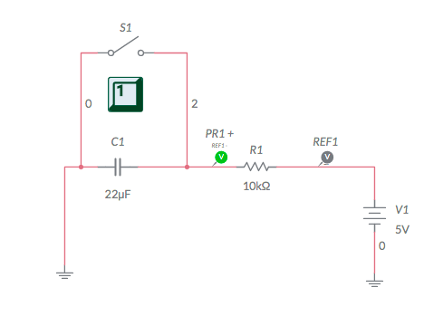

Figure 16: Capacitor Charging and Discharging Simulated Circuit

Figure 16 is a schematic representation of the simulated circuit that was used to compare the results from the physical circuit constructed during the lab. The circuit is composed of a DC voltage source connected to ground, a resistor, a 22 mF capacitor, and a switch. Although the lab instructed for a 10 mF capacitor, the 22 mF was inputted in order to remain consistent with the physical values calculated. A switch is used in the circuit to charge and discharge the capacitor and to graphically show the rate of the voltage across the resistor, which can be seen in Figure 17. The simulation was run with the switch initially closed and immediately opened right after it began.

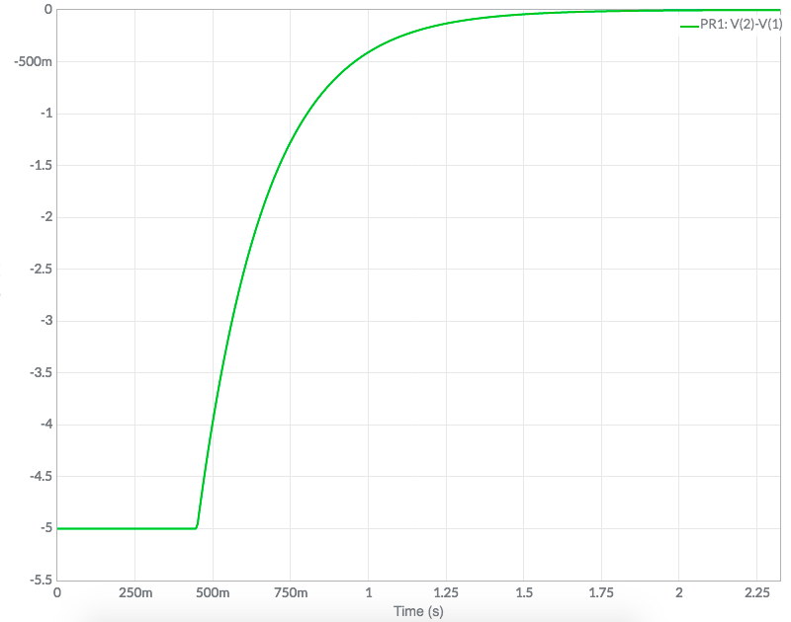

Figure 17: Expected Voltage Output Across Resistor in RC Circuit

## Physical Circuit

The physical circuit was constructed using an electrolytic capacitor. When building the circuit, initially the switch was connected in series with the capacitor which caused it to not have any affect when opening it and closing it.

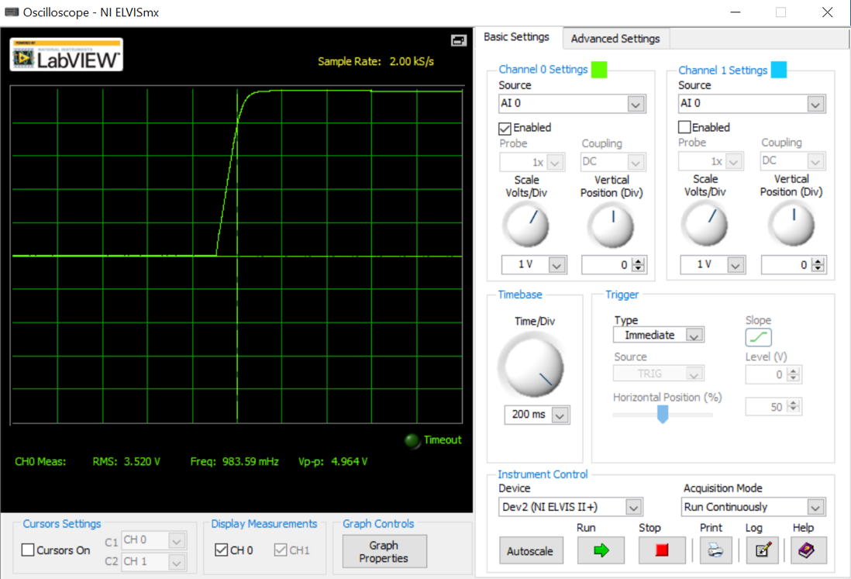

Figure 18: Recorded Voltage Output Signal in RC Circuit

## Questions

1. **Using Equation 7 and Equation 8, determine how long it takes in terms of for the capacitor to become halfway charged.**

By inputting Equation 8 into Equation 8, the modified Equation 8 becomes:

Ideally when a capacitor is halfway charged . With in this circuit, would be equal to 2.5 V when halfway charged. Inputting these values and simplifying through, the time it takes for the capacitor to become halfway charged in terms of the time constant is:

1. **Based on the logs in the simulated and physical circuits, calculate the time constant of the circuit.**

As mentioned prior in this section, after one time constant the voltage across the capacitor would be charged to 0.63. With V in the simulated circuit, the expected voltage after one time constant is expected to be 3.15 V.

1. **What are the differences between the time constants if any, and why?**
2. **If an AC signal were the input, would you expect this circuit to be a high pass or low pass filter? Why?**

This circuit will behave as a high pass RC filter. A high pass filter allows for high frequency signals to pass while impeding lower ones. With the capacitor in series with the resistor, the capacitor blocks low frequency signals that comes from a DC source. The AC signal would be able to pass through meaning a high frequency is able to pass along the circuit.

# Conclusion

After completion of the Manual Circuits lab, all the objectives were met. All the simulated circuits and physical circuit were successfully constructed. In doing so, not only was knowledge regarding the electrical components gained, but troubleshooting strategies were also learned.

There were very few issues creating the simulated circuits as using Multisim was relatively straightforward, however, creating the physical circuits posed more of a challenge. This was a challenge because prior to beginning the experiment, none of the group members knew how to operate the NI ELVIS board so there was a bit of a learning curve. Once the component of the board and the software were figured out, building the circuits was not too challenging. By the end of the lab, all the group members were comfortable using the NI ELVIS board and all its tools.

Looking back at the experiment there are a few major sources of error when comparing the theoretical and experimental results. The main and most prominent one being the tolerances with the electrical components as well as the resistance in wires. When calculating the values in the ideal case, a 100k resistor can be interpreted at face value when the resistor used during the lab was only 98.241k (See Figure 19).

Figure 19: 100k Resistor Reading

This shows that the simulated circuits can be a good benchmark when prototyping a design, but the physical circuit will in most cases be slightly different. They can provide insight on big picture performance metrics but will never exactly replicate the actual circuit. This shows the importance of considering tolerance when designing any type of circuitry. For example, one can construct the ideal circuit and conclude that real live performance will never exceed the ideal performance.

Overall, completion of this lab successfully provided a good learning experience. The information learned in this lab as well as the troubleshooting and hands on experience will come in handy for the following labs.

# References

1. Escalona, L. “Electrical Circuits and Components.” ME 330 – Mechatronics. San Diego State University. Lecture
2. Escalona, L. “Analysis of Electrical Networks.” ME 330 – Mechatronics. San Diego State University. Lecture
3. Instruments, National. *PRODUCT FLYER NI Educational Laboratory Virtual Instrumentation Suite (NI ELVIS)*. National Instruments, https://www.ni.com/pdf/product-flyers/ni-elvis.pdf.

# Appendices

VOLTAGE DIVIDER

Voltage across 100k

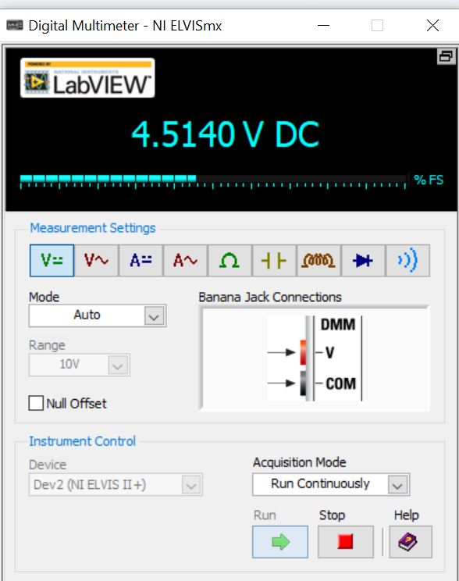

Voltage across 10k

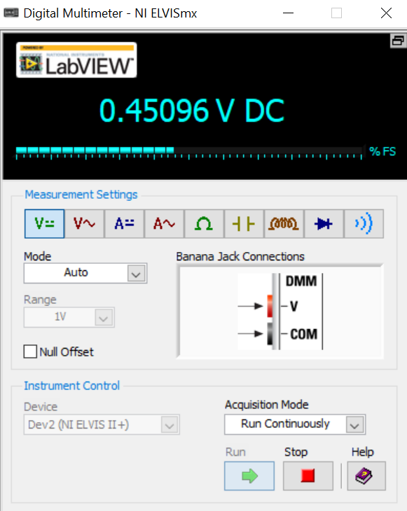

Current through circuit

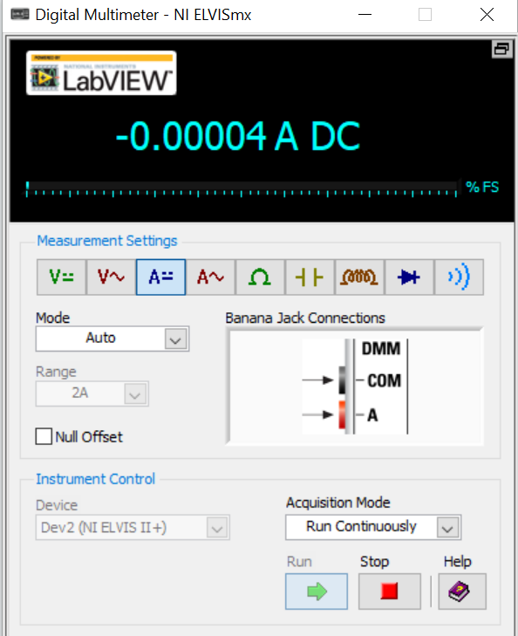

HLAFWAVE RECTIFIER

CAPACITOR



SOURCES

<https://www.ni.com/pdf/product-flyers/ni-elvis.pdf>

1.